DRY SOCKET

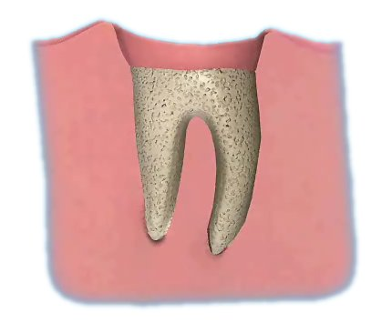

Q What is a dry socket?

A A dry socket occurs when the blood clot in an extraction socket disintegrates and stops the natural healing process. It happens in about 5% of extractions.

Q Why does a dry socket form?

A Some things are known to damage the blood clot such as excessive rinsing out and smoking. Other dry sockets occur for no obvious reason.

Q Can it be treated?

A This very painful but not serious condition can be treated by placing a pain relieving dressing in the socket. Antibiotics are not usually needed.

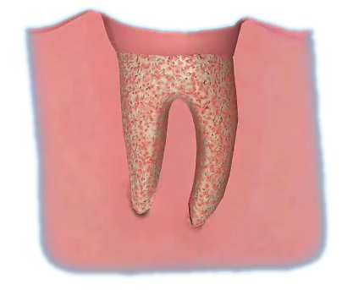

Q What does it involve?

A The aim of the treatment is to relieve pain and enable the wound to heal.

Q What if I don’t have the treatment?

A The socket will eventually heal without treatment but will be very painful.
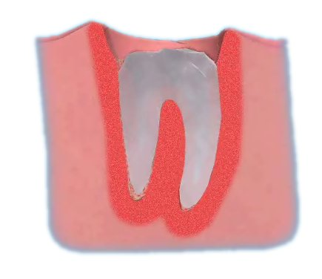

Q What about aftercare?

A The dressing placed in the socket usually dissolves away by itself.

